**UNLOCKING INSIGHTS INTO THE GLOBAL AIR TRANSPORTATION NETWORK WITH TABLEAU**

1. Introduction:

* 1. Overview:

This project is explains about air transportation lines and give information about number of airlines with respect to its country, world map showing details of all airports within a country, pie chart for source airport and destination airport, airlines within a country and airlines and their stops.

1.2 Purpose:

Purpose of this project is gives an idea about airlines and to know their codes (IATA and ICAO) with country, their latitudes and longitudes, active status of airlines, altitudes of countries are able know.

2. Problem Definition & Design thinking:

2.1 Empathy map:

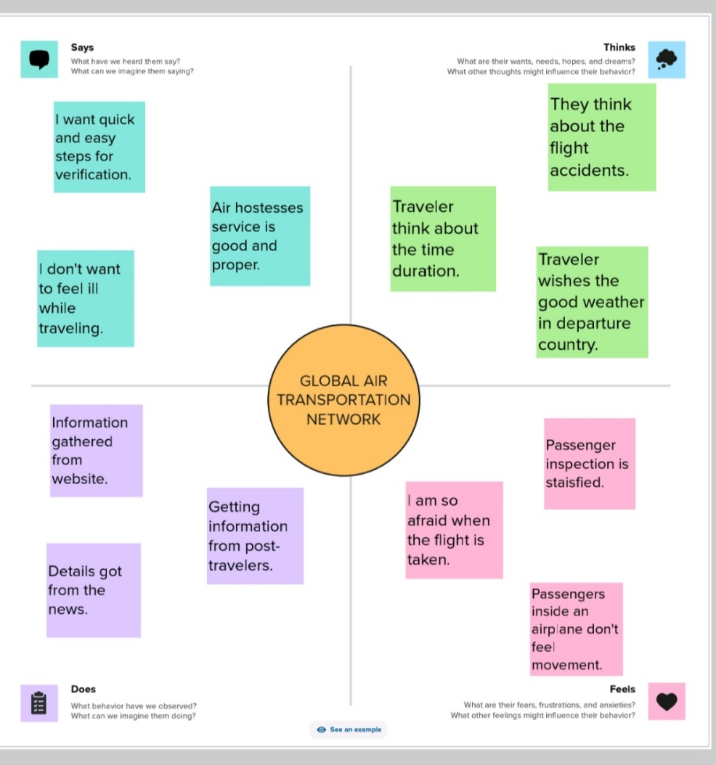

2.2 Brainstorming map:

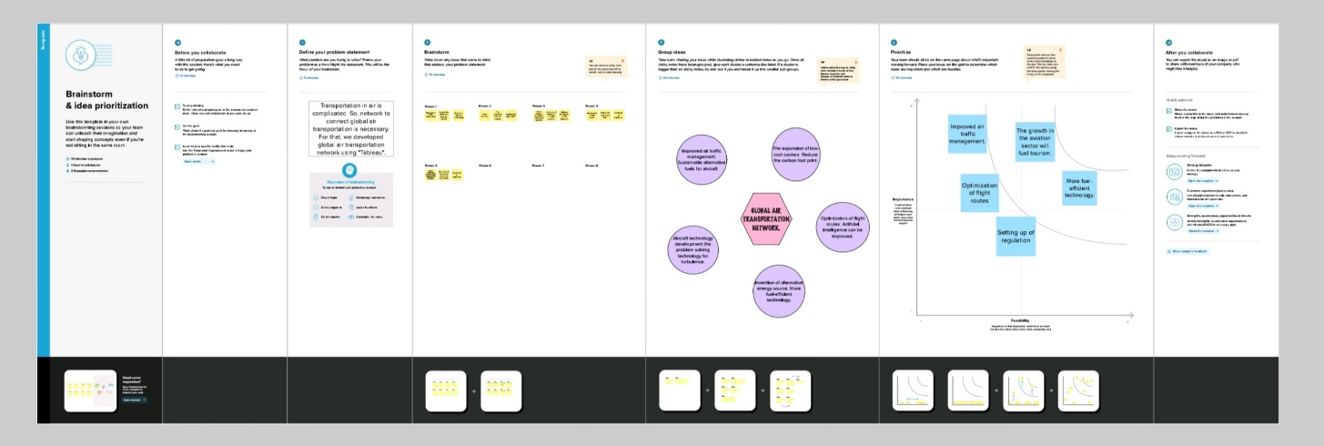

3. Result:

1. Dashboard:

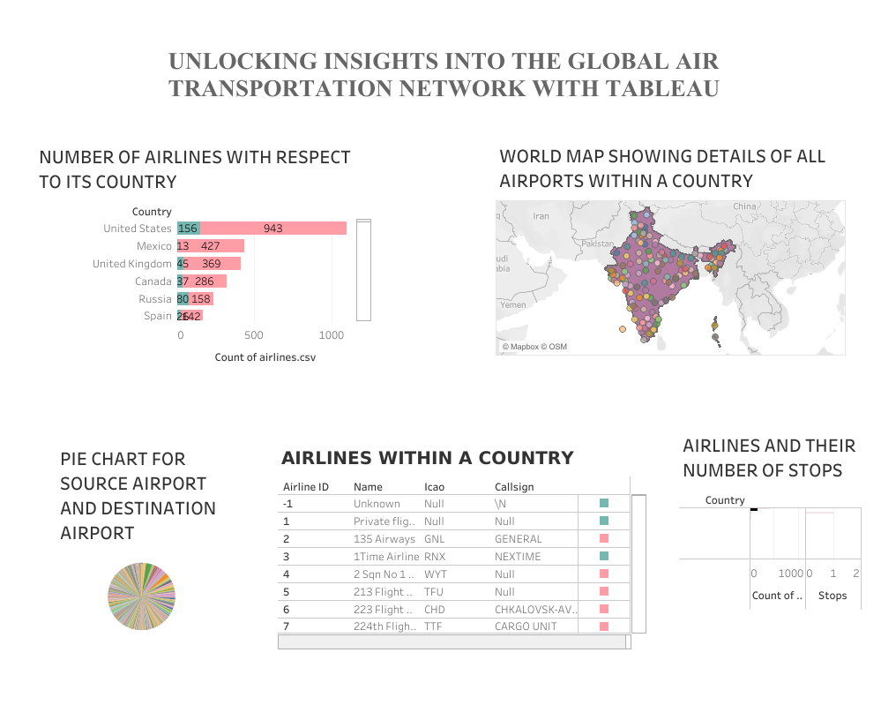

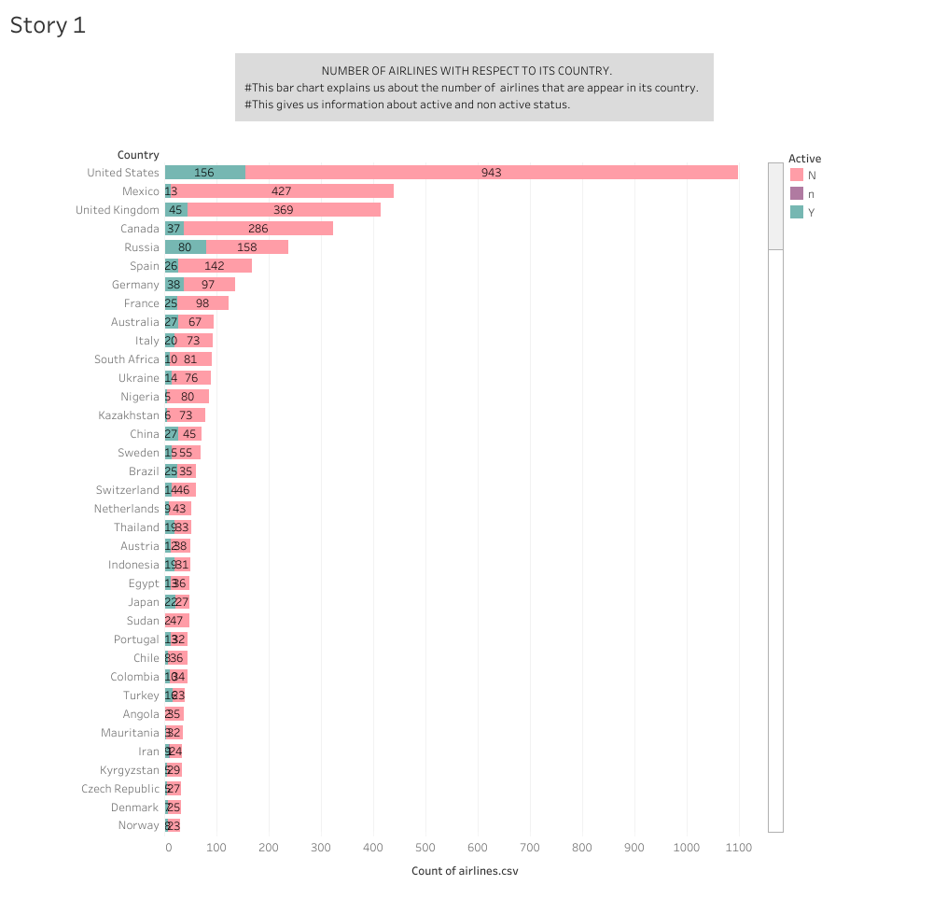

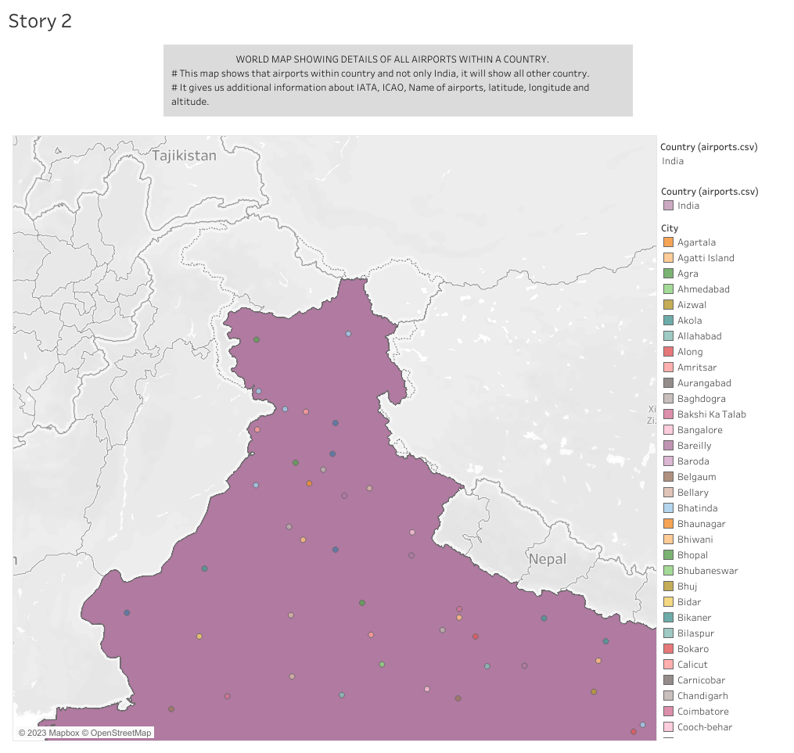

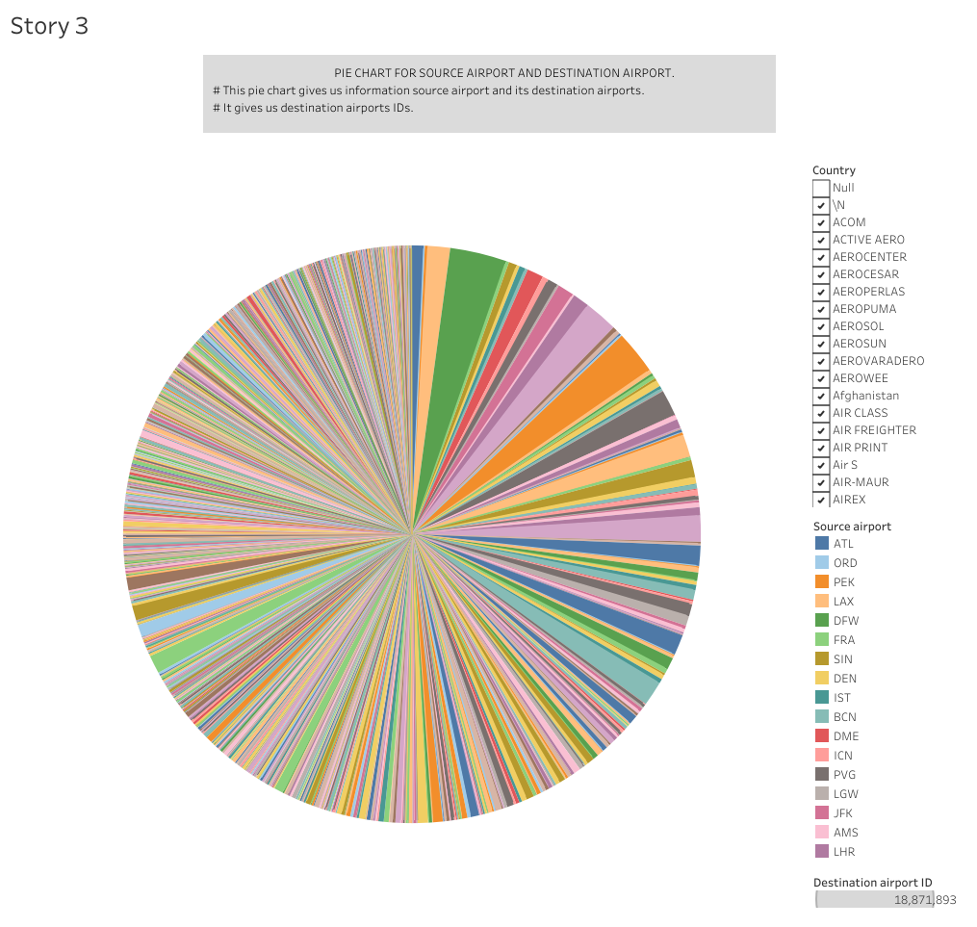

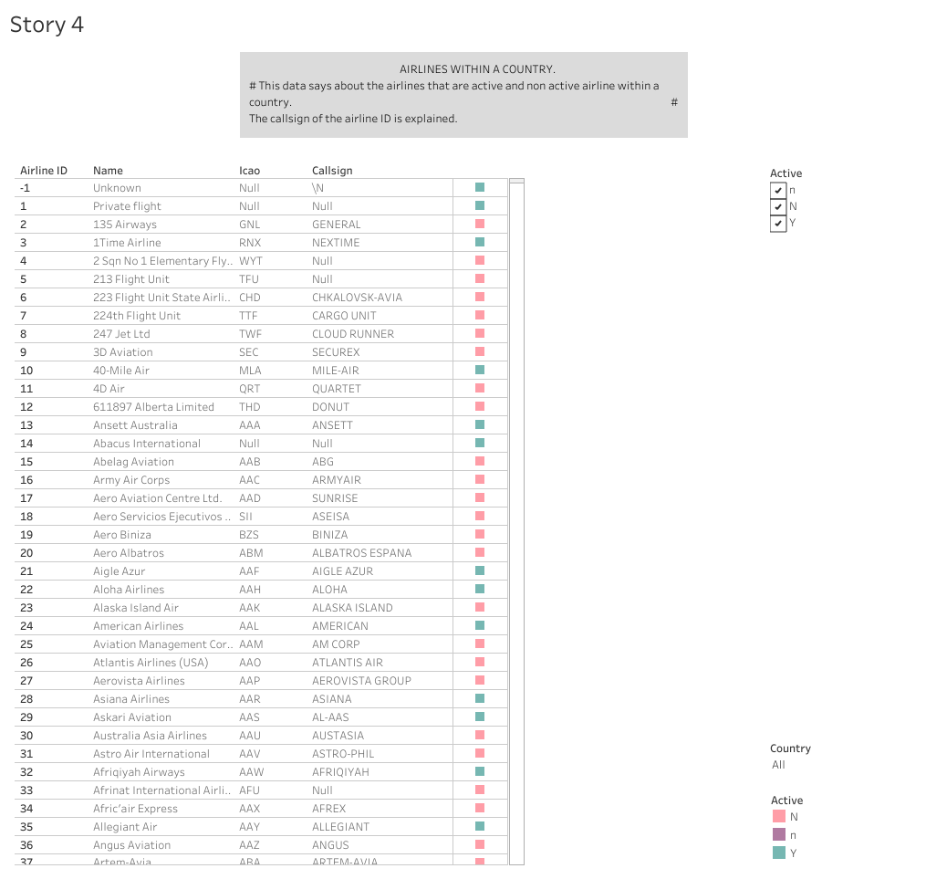

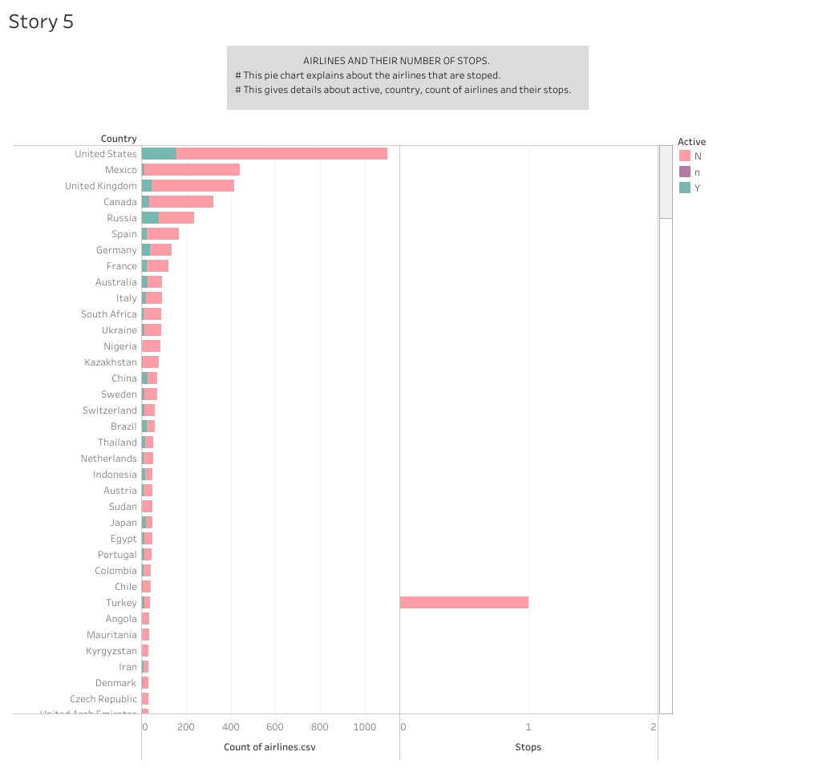

4. Advantages:

* There is no faster transport service than air transport.
* One of the most advantageous features offered by air transport is its speedy delivery times.
* Air transport is the only means of transportation that does not support physical limits.
* It is one of the means of transportation that offers practically no interruption in its service, which is very attractive for companies.
* Delays in delivery dates or loss of goods are options that can be very difficult to achieve with this means of transport.
* No other means of transport in the logistics sector can cover such long distances as air transport.

Disadvantages:

* There is no doubt that air transport is the least economical means of transportation compared to other types of transport.
* The cost of infrastructure, fuel makes air transport economically superior to other alternatives.
* Storage capacity is lower than land and sea transport. This is a clear disadvantages air transport is ideal for medium or low loads, but is not so attractive for large volumes of goods.
* Air transport, due to its specific characteristic, cannot carry certain products or goods.

APPLICATIONS:

* Sheet 1 used to know about the number of airlines with respect to its country and it shows the active status.
* Sheet 2 shows about the world map showing details of airports within country and gives additional information about IATA, ICAO, name of airports, latitude, longitude and altitude.
* Sheet 3 is pie chart and it shows about source and destination airport. Destination airport is able to known.
* Sheet 4 data says about airlines within a country and the call sign of the airline ID is explained.
* Sheet 5 is also pie chart but this says about airlines and their number of stops.

6. CONCLUSION:

This project is all about the airlines and gives information about number of airlines with respect to its country, world map showing details of all airports within a country, pie chart for source airport and destination airport, airlines within a country and airlines and their number of stops. The empathy map and brainstorming maps are created

7. FUTURE SCOPE:

* The most recent estimates suggest that demand of air transport will increase by an average of 4.3% per annum over the next 20 years.
* If this growth path is achieved by 2036 the air transport industry will then contribute 15.5 million in direct jobs and $1.5 trillion of GDP to the world economy.

PROJECT NAME: Unlocking Insights into the Global Air Transportation Network

TEAM LEADER: G. Ilayarani.

TEAM MEMBERS:

* M. Dharshini
* B. Dhibakar
* T. Haritha
* V. Purushothaman

DEPARTMENT: Physics III year

COLLEGE NAME: Shree Raghavendra Arts and Science

College.